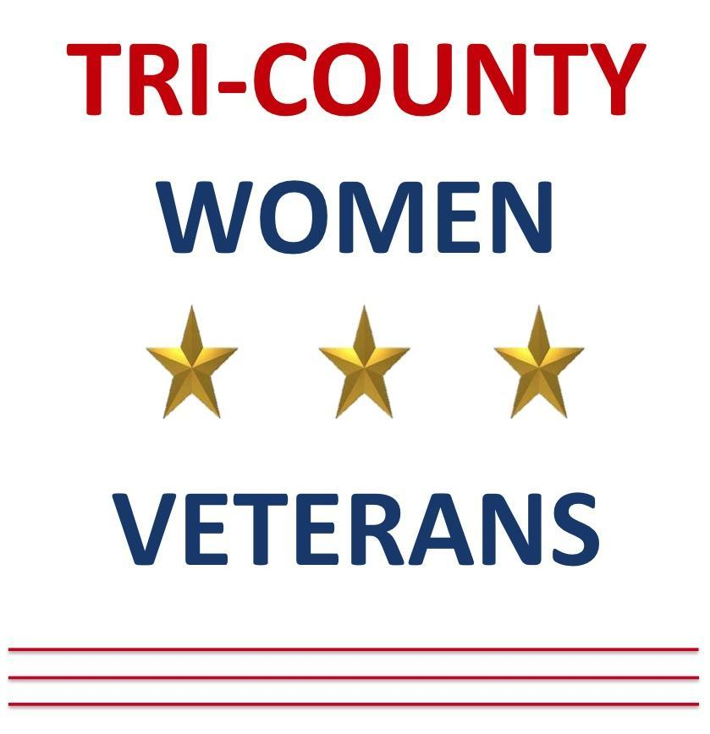
Tri-County Women Veterans Meeting Minutes
September 21, 2026
This document captures a comprehensive summary of a Tri-County Women Veterans meeting, featuring organizational updates, upcoming events, fundraising efforts, member engagement, and a special presentation by Scott Matham, CEO of the Veterans Museum. Key topics include event logistics, new initiatives, community partnerships, personal stories, and a detailed overview of the Veterans Museum’s mission to preserve veterans’ oral histories.

Key Takeaways
- Active Community Engagement: The Tri-County Women Veterans group is highly active, with robust fundraising, social events, and support initiatives.
- Veterans Museum Impact: The Veterans Museum’s oral history project is a powerful tool for healing, recognition, and legacy-building, especially for women veterans.
- Leadership and Storytelling: Community engagement, leadership development, and intergenerational storytelling are central to the group’s mission and ongoing success.

Meeting Logistics & Announcements
- Event Transportation & Wreaths Across America
  - Bus transportation available for the December 19th event; open to all volunteers, not just board members.
  - Volunteers can sponsor wreaths until December 2nd; typically, only two wreaths are distributed at a time, but exceptions are sometimes made.
  - Cindy Bentley, Bushnell location coordinator, will address questions in October.
  - Volunteers can sign up via a dedicated link (wreathsacrossamerica.org/fl0252) or through flyers and QR codes.
- Website & Membership Support
  - Issues with the website or membership applications can be resolved by contacting the organizer directly.
  - Assistance provided for logging in, password resets, and profile updates.
  - New members are added to the website as site members upon application.
- Volunteer & Committee Opportunities
  - Open positions: Marketing Chair and fundraising committee members.
  - Emphasis on fun and community in committee work.
  - Recognition for volunteers’ contributions, including successful fundraising at polling events.

Fundraising & Social Events
- Recent & Upcoming Events
  - Fundraisers: Taste and Tales food tour, Dine to Donate, Honey Baked Ham, fashion show, Portillo’s (Oct 22), Chipotle for Good (Nov 17), bingo, murder mystery (February), and a poker run (Nov 27).
  - Trivia Night and art therapy events seeking more volunteers and RSVPs.
  - Talent show scheduled for January 15th, primarily for women veterans and their families.
  - Baskets donated to Salvation Army, Shoebox, and Visiting Angels.
- Special Partnerships
  - Mickey Fanatics club donated $1,700 and pledged continued support for the Flight of Recognition program.
  - Recognition of the importance of women veterans and their unique contributions.

Membership & Merchandise
- Membership Updates
  - Current membership count at 35; mentors recognized with special stars.
  - “Meet the Board” night scheduled for October 12th at Pinellas Library, including group history, goals, and refreshments.
- Merchandise
  - PGA Store donated 100 sweatshirts for fundraising ($10 each or $20 for three).
  - Custom Apparel offers embroidered items; orders must be picked up at the store.
  - Upcoming holiday-themed Zentangle cards by Joan, available for $1 each.

Social & Support Initiatives
- Soup-Off Event
  - Encouragement for members to join the $40 soup-off event featuring nine restaurants and voting for the best soup.
- Oral History Project
  - Emphasis on the importance of all members’ stories, regardless of length of service.
  - Plans to set up a trauma support group and openness to new project ideas.
- Birthday Celebrations
  - Group recognition of September birthdays and a special card for a 100-year-old Korean War veteran.

Financial Report
- Budget & Fundraising
  - August income: $15,500; expenses: $3,000; net: $12,000.
  - Total assets: $157,712, with funds allocated to various projects.
  - Successful fundraisers: America 250 event ($2,100), Wednesday Warriors ($11,000), Petrina concert and bingo events (each nearly $4,000).
  - Progress toward project goals: Flight of Recognition (52%), Bushnell Monument (6%), Wreaths (45%), H-Bot (92%).
- Finance Committee
  - Call for new members to join and eventually take over committee roles.

Governance & Elections
- Upcoming Elections
  - Positions up for vote: President, VP3, VP4.
  - Candidates: Betsy Nolan (President), Kelly Dobson (VP4).
  - Need for volunteers to shadow or step into leadership roles.

Veterans Museum Presentation by Scott Maythan

Museum Mission & Process
- Origins & Purpose
  - Founded after Hurricane Irma inspired the preservation of veterans’ stories.
  - Interviews recorded, transcribed, and archived in the Library of Congress and featured on interactive kiosks in public spaces.
- Interview Experience
  - Interviews are chronological, exploring childhood, service, and post-military life.
  - Veterans receive copies of their recordings and transcripts.
  - The process is therapeutic, especially for those who have not shared their stories before.
- Kiosk Deployment
  - Kiosks placed in state veterans homes, libraries, and museums; stories updated weekly.
  - Special kiosks focus on women veterans, with 85 interviewed and 65 stories featured.

Sample Stories & Impact
- Diverse Experiences
  - Stories included: Navy sea stories, women breaking barriers in aviation, combat nurses in Vietnam, National Guard leaders, and post-9/11 Army drivers.
  - Example: A Vietnam flight nurse recounts caring for gravely wounded soldiers and the emotional toll.
  - Example: A woman veteran describes learning to drive in the Army and facing combat in Iraq.
- Women Veterans
  - Many women express that the interview process was the first time they felt truly recognized as veterans.
  - Issues of recognition, respect, and the unique challenges faced by women in the military are highlighted.
- Community & Legacy
  - The project fosters intergenerational understanding and preserves personal histories for future generations.
  - Families cherish the recordings as heirlooms; veterans in homes gain community recognition.
- How to Participate
  - Members encouraged to sign up for interviews through Tri-County Living Paths, not directly via the museum website.
  - Plans to add sign-up links and information to the group’s website.

Closing & Additional Announcements
- Next Steps
  - Continue gathering oral histories, with a goal of 435 sign-ups.
  - Efforts underway to secure a kiosk at Eisenhower Rec Center at a reduced cost.
- Personal Updates
  - Members shared personal health and caregiving experiences, especially related to VA benefits and eligibility.
  - Guidance provided for navigating VA claims, especially for Camp Lejeune water contamination.
- Final Remarks
  - Meeting adjourned after birthday celebrations, 50/50 raffle, and open floor for last announcements.
Attachments presented:
TCWVSeptember2026 Presentation.pptx VP2 Fundraising Slides for Sept 2026.pptx
Gen Member Agenda September 21 2026.docx VP2 Fundraising Slides for Sept 2026.pptx
4th Atr Art Flyers.pdf
Aug Chairty progeess.pdf
Expo Flyer 9.01.26 update.pdf
TCWV HOLIDAY PARTY FLYER 2026.pdf
VP1 Tri-County Women Veterans VP1 Sept 2026.pptx
VP2 Fundraising Slides for Sept 2026.pptx

